MONGO Database (No SQL)

Week #1

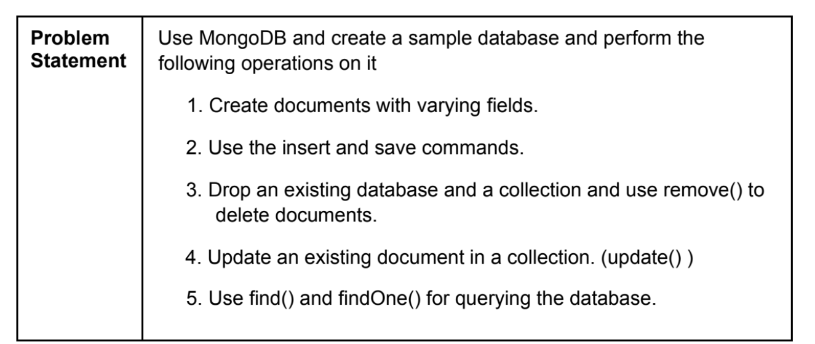

**1.Create Operations**

Create or insert operations add new documents to a collection. If the collection does not currently exist, insert operations will create the collection

**Insert one :**

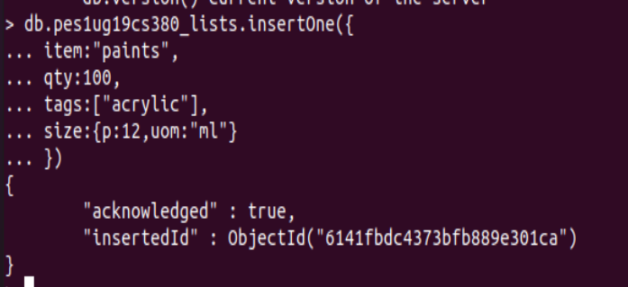

**Insert Many:**

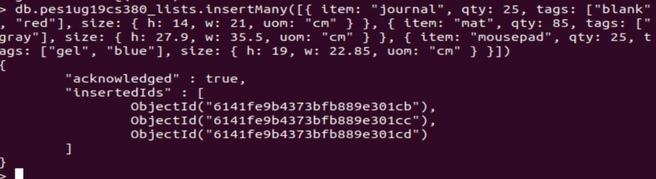

**2. Read Operations**

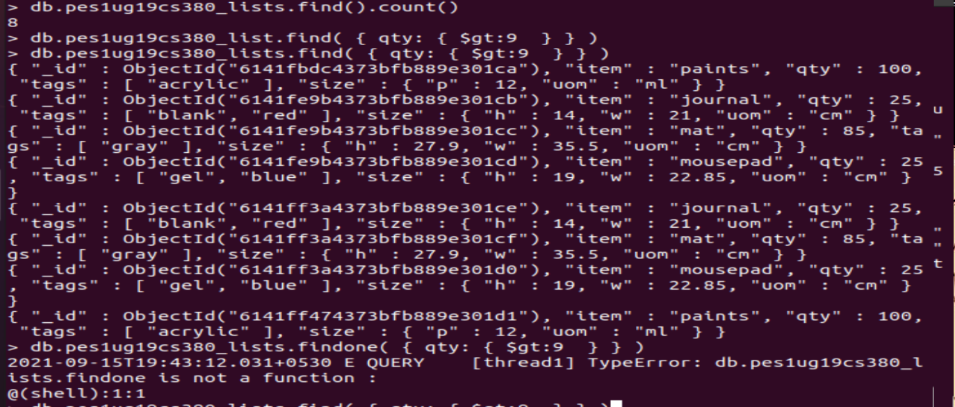

**3.Update Operations**

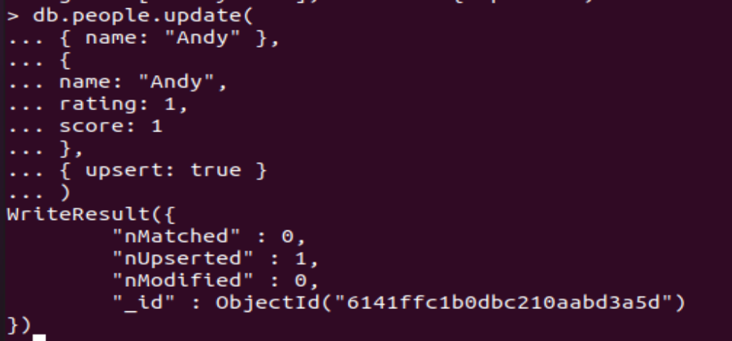

**4.Delete Operations**



**Mongo DB Demo:**

Making 4 collections[towns, PES1ug19cs380_studentlist phones, pes1ug19cs380_shop_inventory], and applying the prior mentioned methods to execute queries and perform CRUD operations create, read, update, and delete on these collections

**/*Create*/**

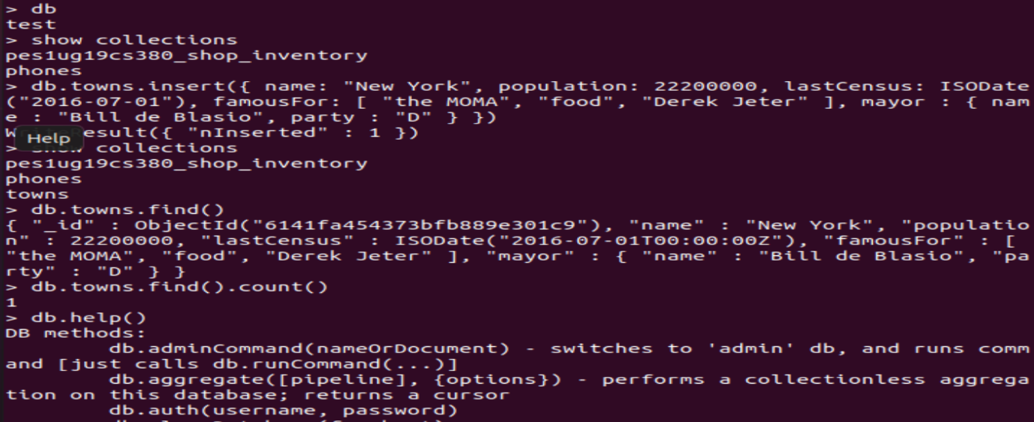

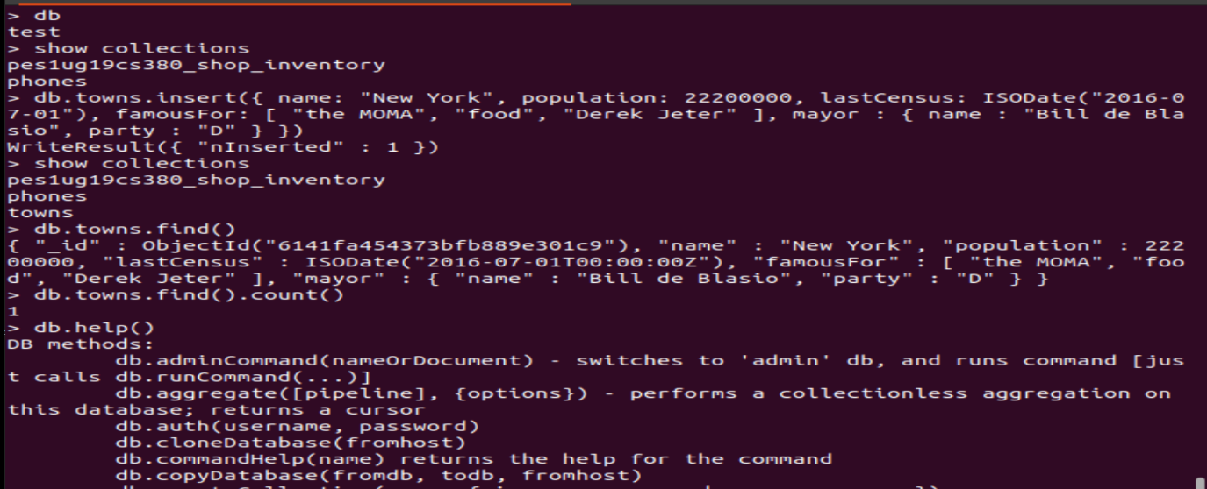

**/*help*/**

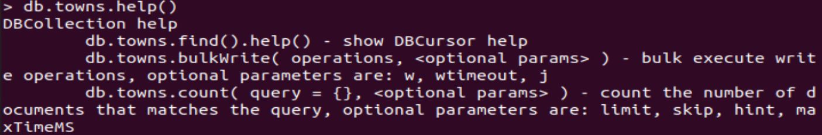

**/*insert*/**

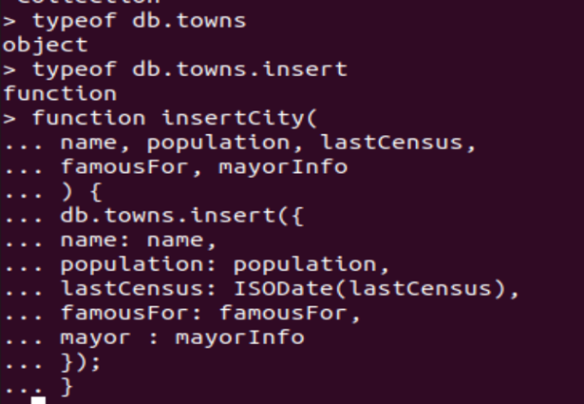

**/*Read*/**

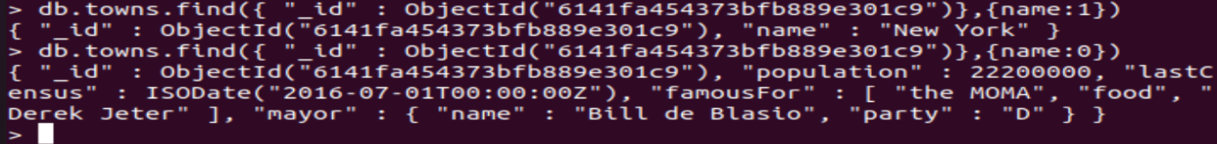

**/* find all towns that begin with the letter P and have a population less than 10,000 */**

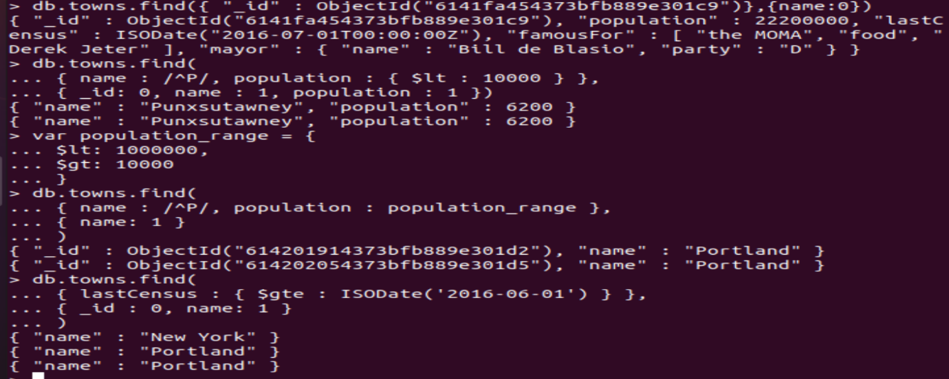

**/* Querying nested data */**

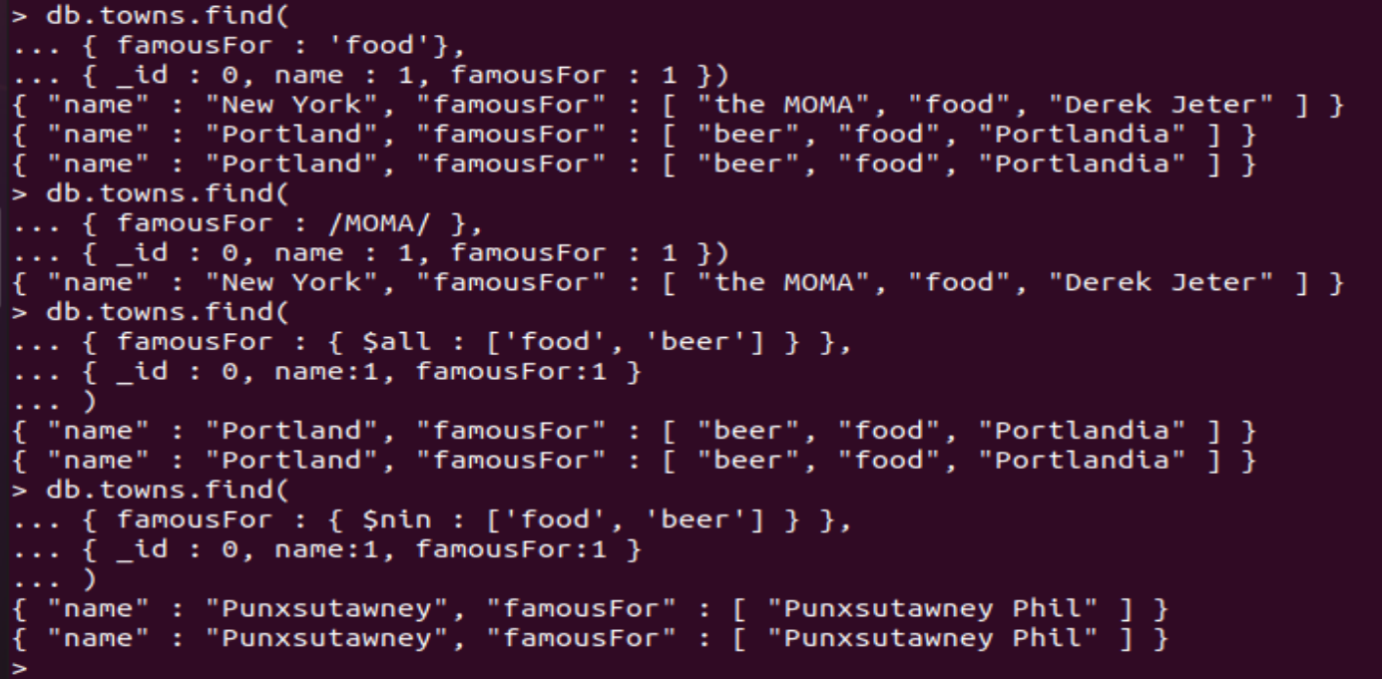

**/* New collection – PES1ug19cs380_studentlist*/**

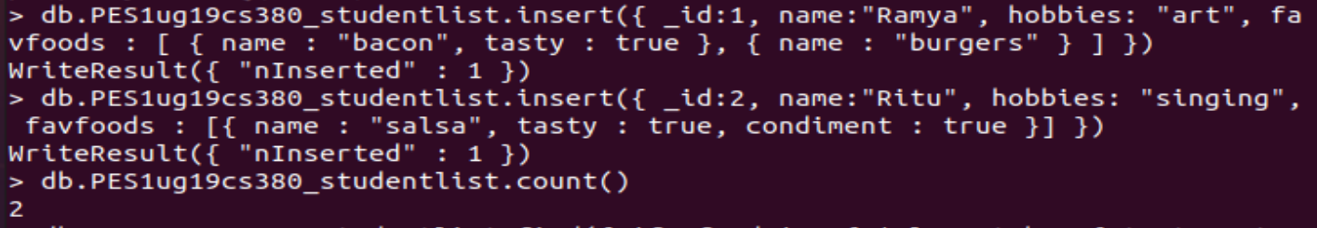

**/*Read*/**





**/*OR*/**



**/*Update*/**



**/* Increment */**

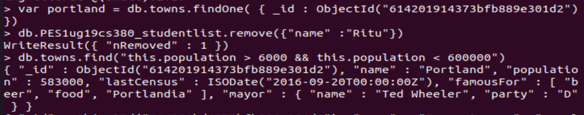

**/* References */**

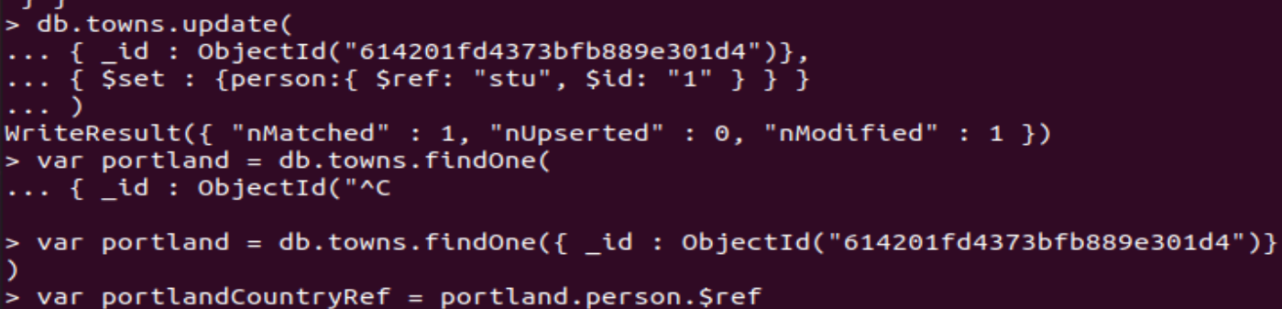

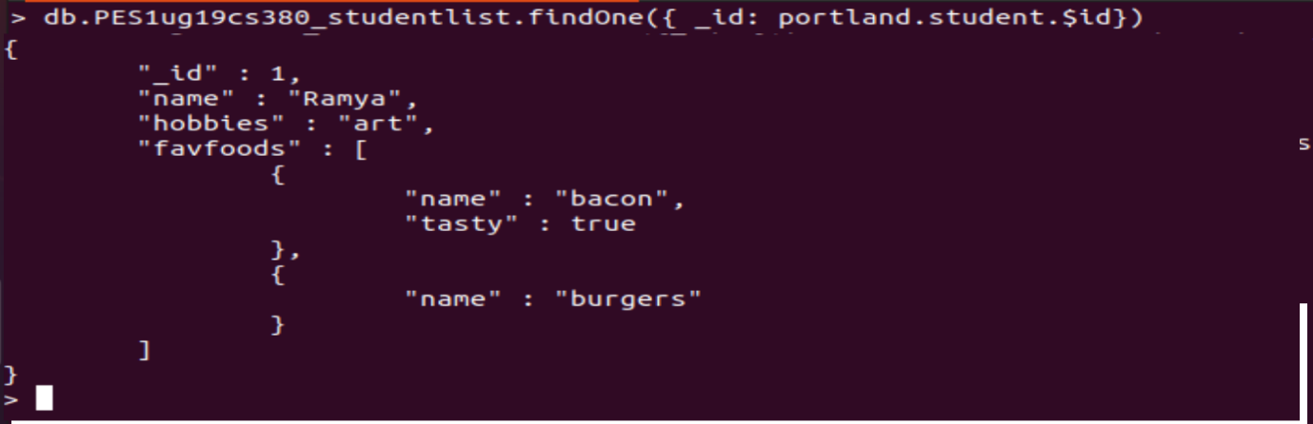

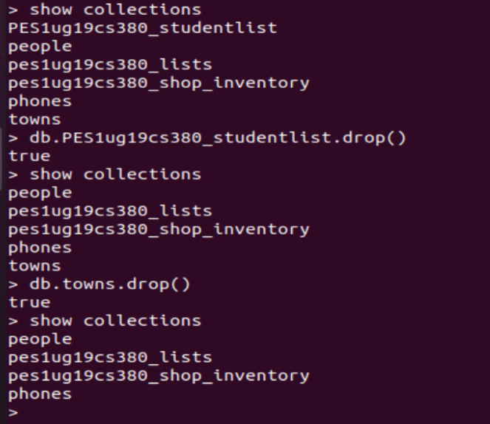

**/*New collections: Phones*/**

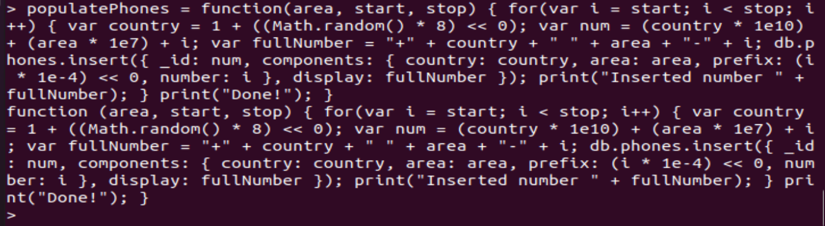

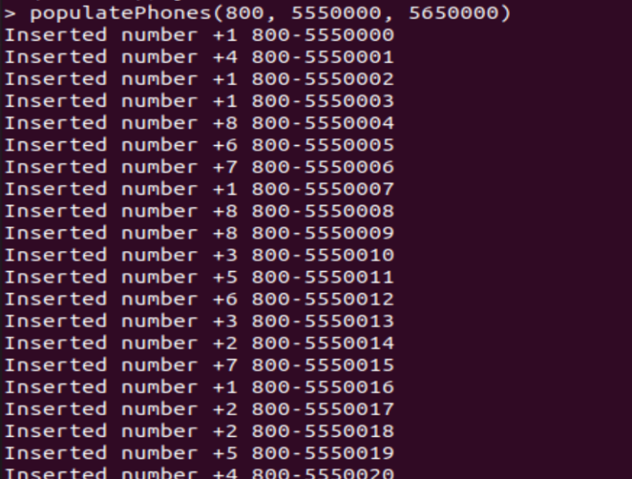

**/* create index */**

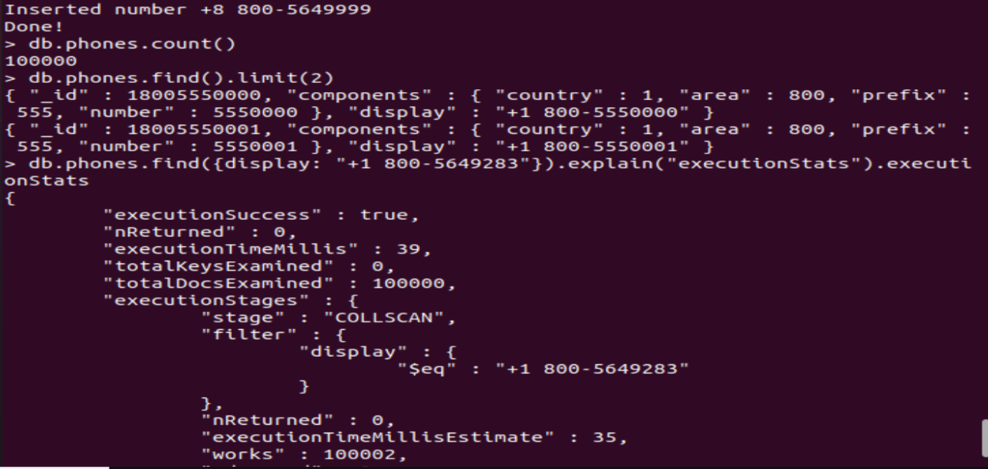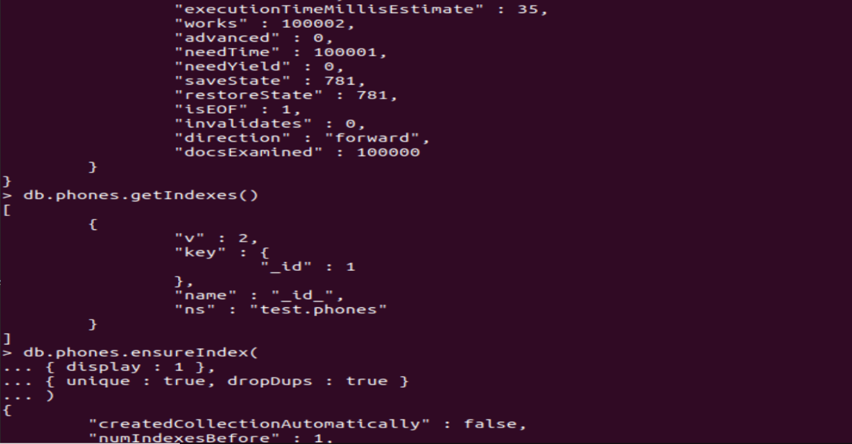

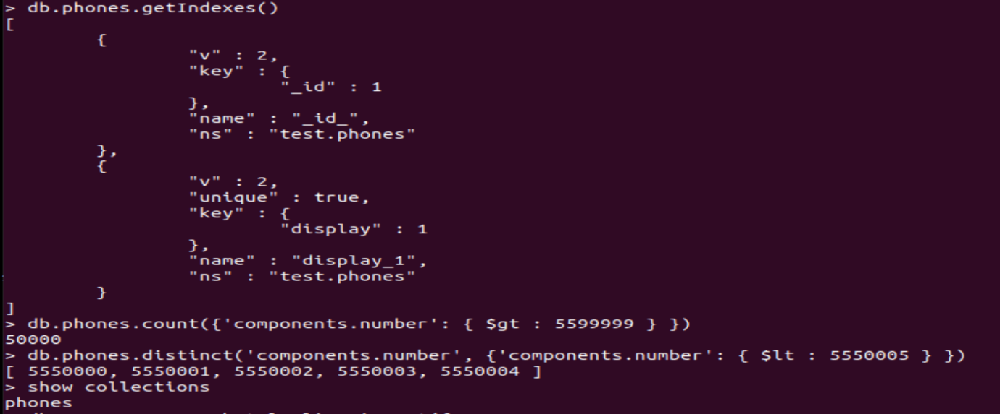

**/* Aggregation */**

